**LTspice的简介**

This piece of instruction aims to give a brief tutorial of LTspice. LTspice is a powerful software that permits to conduct time-domain simulation and parameter sweep. For the following part, examples will be provided to illustrate the usage of this software.

本介绍旨在对LTspice 基本操作进行简单的说明。LTspice 软件功能强大，它能进行时域仿真和DC参数扫描分析。 以下，我们举例说明LTSPICE软件的用法。

1. **Build-up**

Open the software LTspice and you will see the window as below. Click on the icon ***New Schematic*** to create a new workspace.

打开LTspice，窗口如下。点击叫***New Schematic***的图标创建一个新的项目。

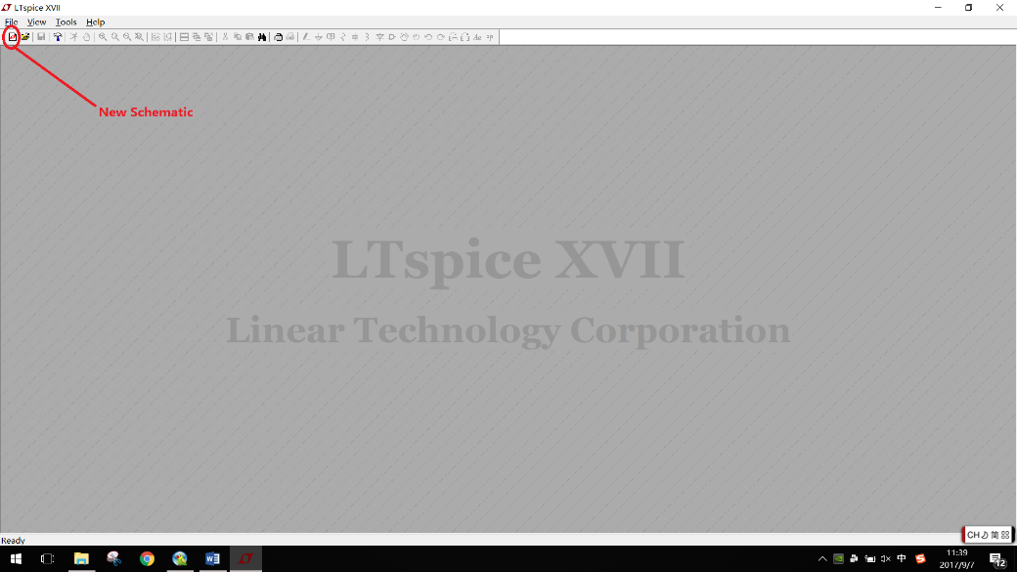

Then in your workspace, add reference point and components.

然后在这个项目中添加仿真元器件。

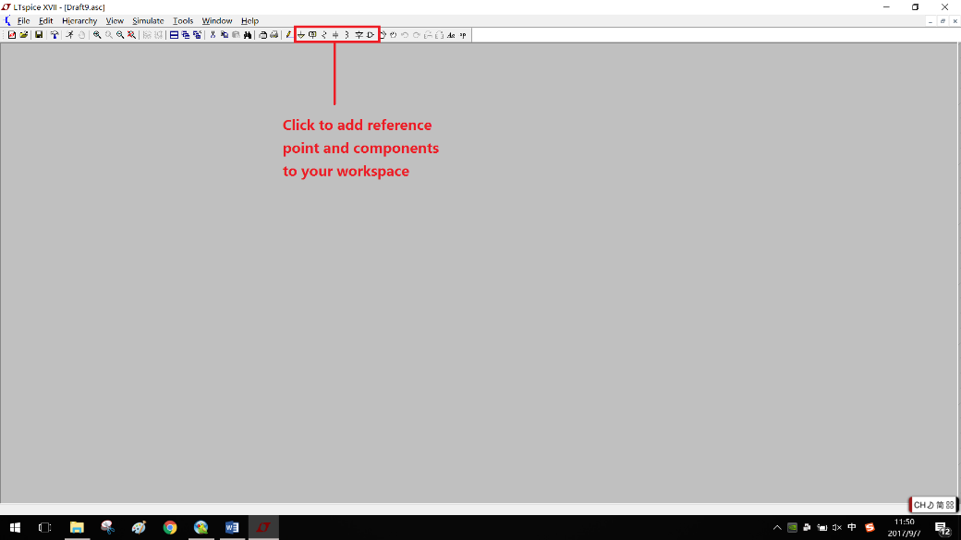

Click on the icon ***component*** then add **nmos** and **voltage source** shown as below.

如下图，点击器件然后添加nmos管 和电压源。

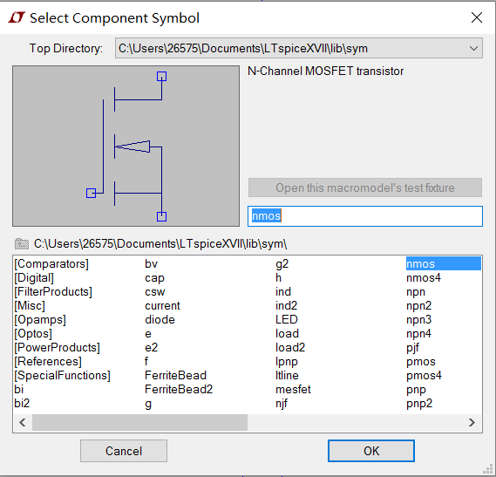 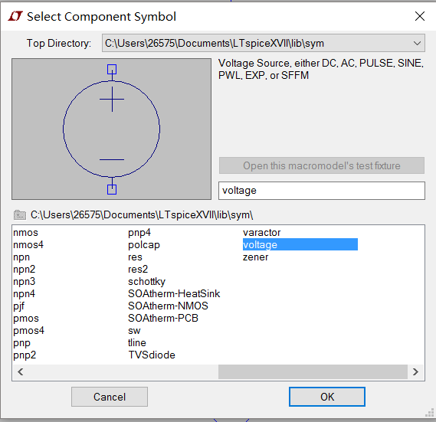

Now you have got all the components you want in your workspace.

现在在项目里包含所有需要的的元器件。

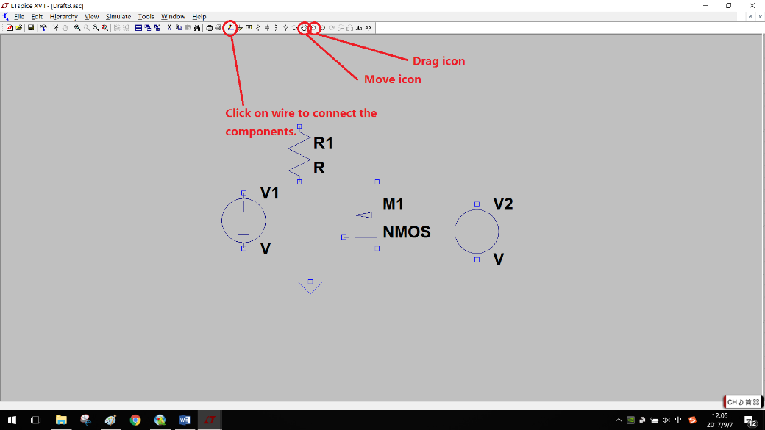

Rearrange the circuit and click on the icon wire to properly connect them together. You will find the icons for changing the position quite useful.

Your circuit topology should be like as below.

整理电路元件，点击***wire***然后把它们连接成回路。

你会发现这个软件改变器件的位置十分方便。

电路拓扑结构如下图。

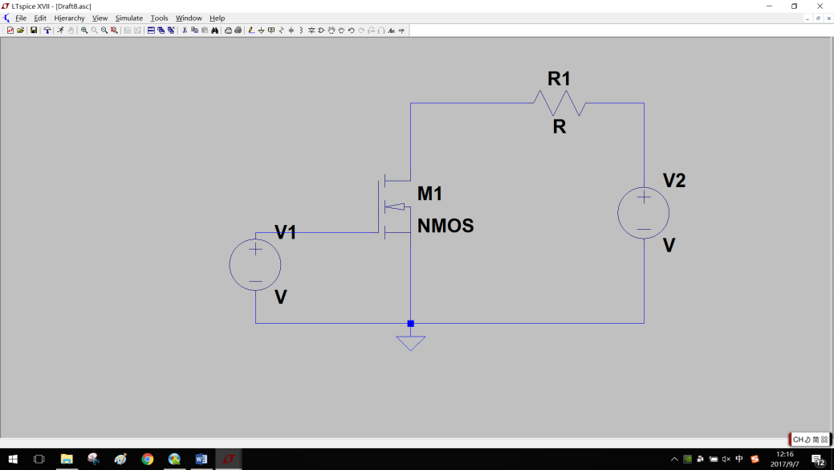

Right-click on each component to configuration. Right-click on text would enable to change the name of each component.

右键点击每个零件进行设置。右键点击标题可以改变每个器件的名称。

* **Resistor电阻**

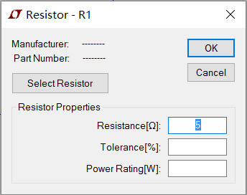

Right-click on resistor **R1** and configure the resistance to be 5 Ohm.

右键点击电阻R1然后设置它的电阻为5 Ohm。

* **MOSFET**

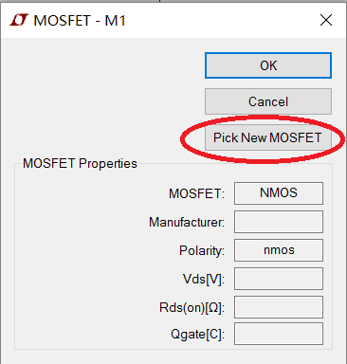

Right-click on MOSFET **M1** and choose ***Pick New MOSFET***.

右键点击***MOSFET*** M1 来选择新的***MOSFET。***

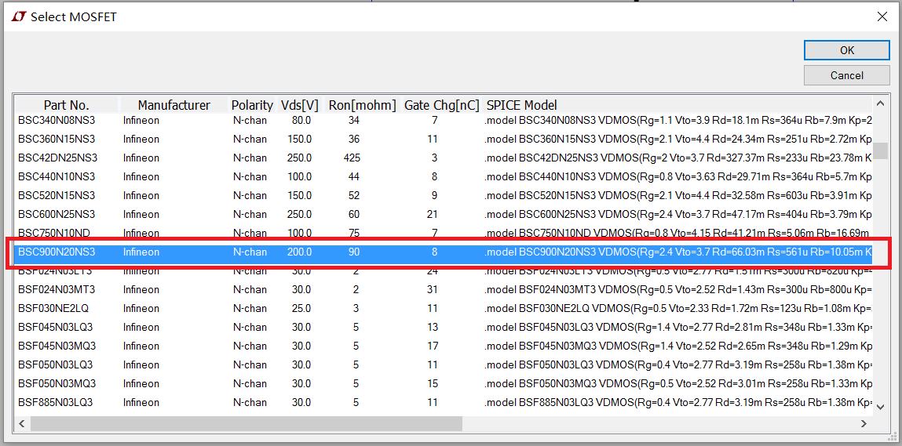

Then select the **Part No.** to be **BSC900N20NS3** which is going to be the model of our illustration.

然后选择编号为**BSC900N20NS3**的器件，作为参考器件模型。

* **Voltage** **Source电压源**

Change the name of the two voltage sources to **VGS** and **VDC** respectively. Detailed configuration of each voltage source will be provided in **Time-domain simulation** and **DC-sweep**.

分别改变这两个电压源为**VGS** 和**VDC**。详细设置每个电压源时域仿真和直流扫描的参数。

1. **Time-domain simulation时域仿真**

In this part, suppose that VDC is set to 10V and VGS is a square-wave signal enabling to turn on and turn off M1 alternatively. What we want to observe include the instantaneous value of **VDS** (the voltage of M1 across D and S terminal), **Id** (the current flowing through M1) and the power dissipated in M1 which could be calculated as VDS*Id.

在这个部分，假设VDC 设定在10V,VGS 为能够使MOSFET　M1顺序开通和关断的矩形波电压信号。我们想观察到的是VDS的瞬时值（M1的D极和S极之间的电压），Id（流经M1的电流）和消耗在M1上的能量，这个能量可以表示为VDS*Id。

* Voltage Source Configuration电压源的设置

First configure VDC to be 10V.

首先设置VDC为10V。

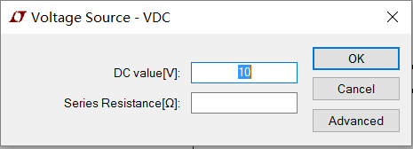

Then configure VGS. Click on ***Advanced.***

然后设置VGS，点击高级。

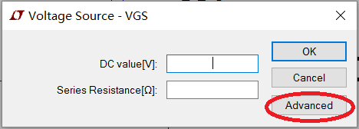

Set VGS to be **PULSE** with a Von of 10V, a frequency of 100us and 50%’s duty cycle.

设置VGS 为PULSE，其中Von为10V，频率为100us 而且占空比为50%.

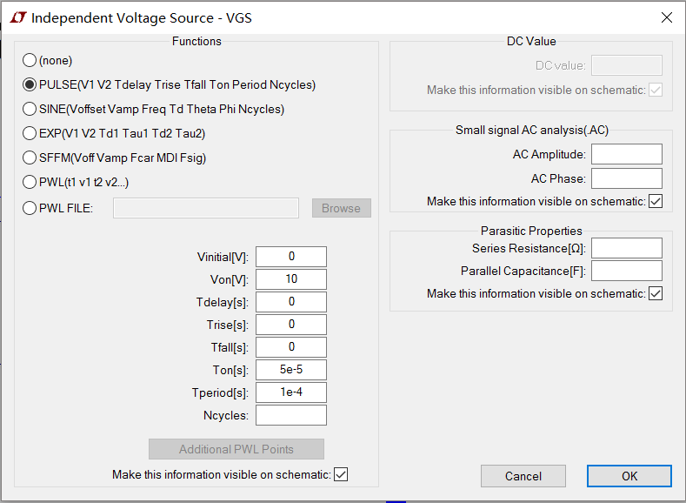

* Simulation command configuration仿真设置

In the menu ***Simulate***, choose ***Edit Simulation Cmd***.

在这个仿真菜单中，选择***Edit Simulation Cmd***.。

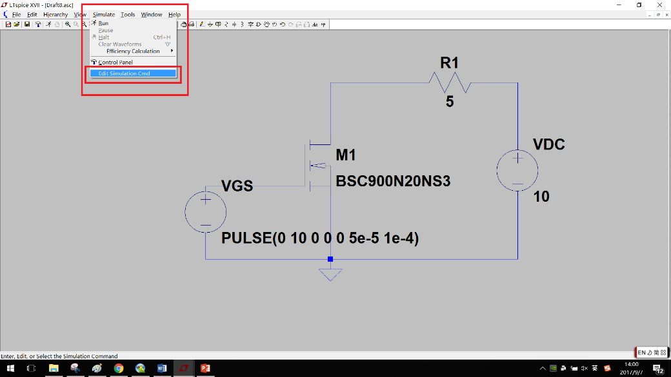

Configure the ***Transient*** option as below.

如下图，设置瞬态选项。

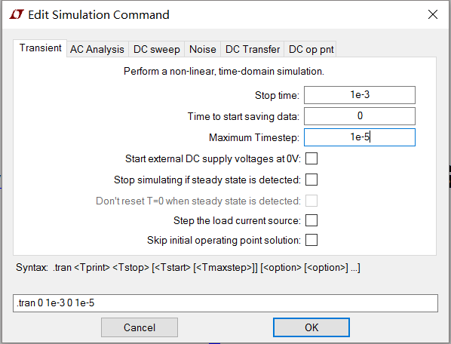

Once these configurations are done, simulation could be conducted. Click on the icon **run** to start the simulation.

当这些设置完成了，仿真就能够进行了。点击run 开始仿真。

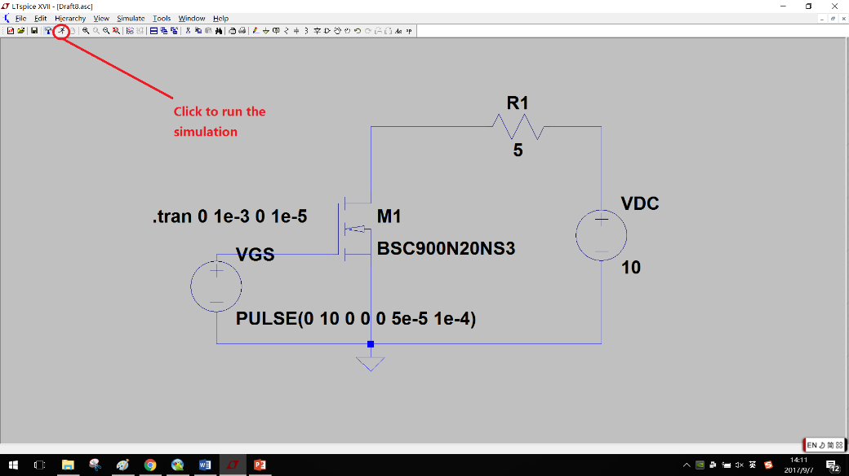

Right-click on the black plot pane and select Add Plot Pane to add two more plot panes.

右键点击黑色窗格，选择Add Plot Pane来添加更多的窗格。

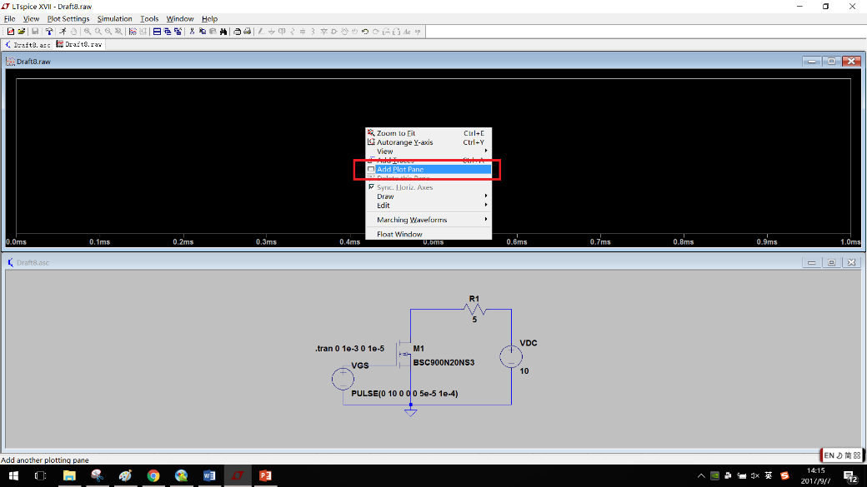

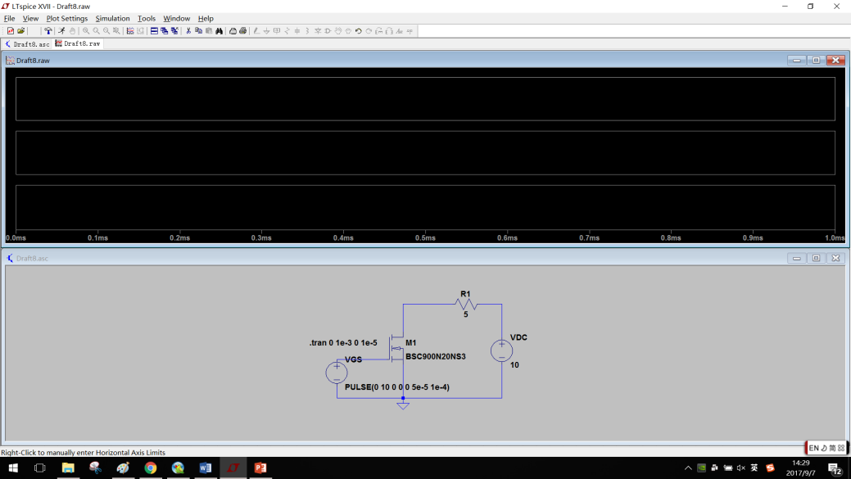

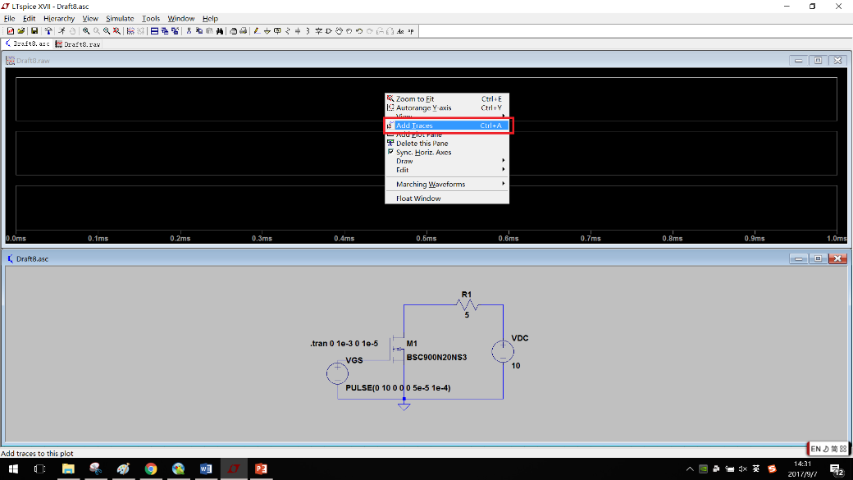

Then in each plot pane, right-click to choose Add Traces. Add V(n001), Id(M1) and V(n001)*Id(M1) to each plot pane respectively.

然后在每个窗格中右键点击来添加曲线。分别在每个窗格中添加V(n001)，Id(M1)和V(n001)*Id(M1)。

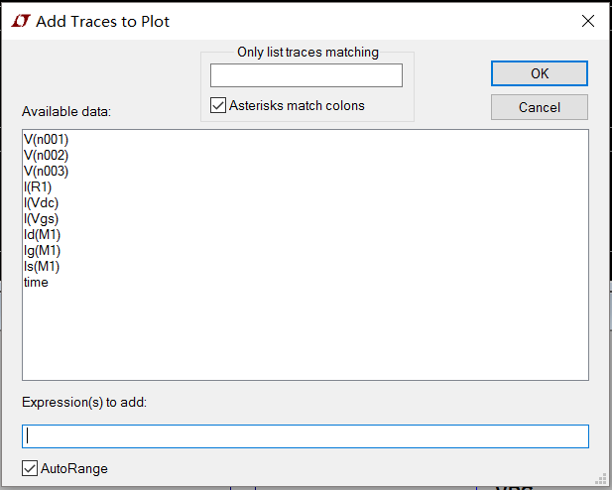

Eventually, you should be able to see the waveform similar to the one given below.

最终，你能够看到和下图相似的波形。

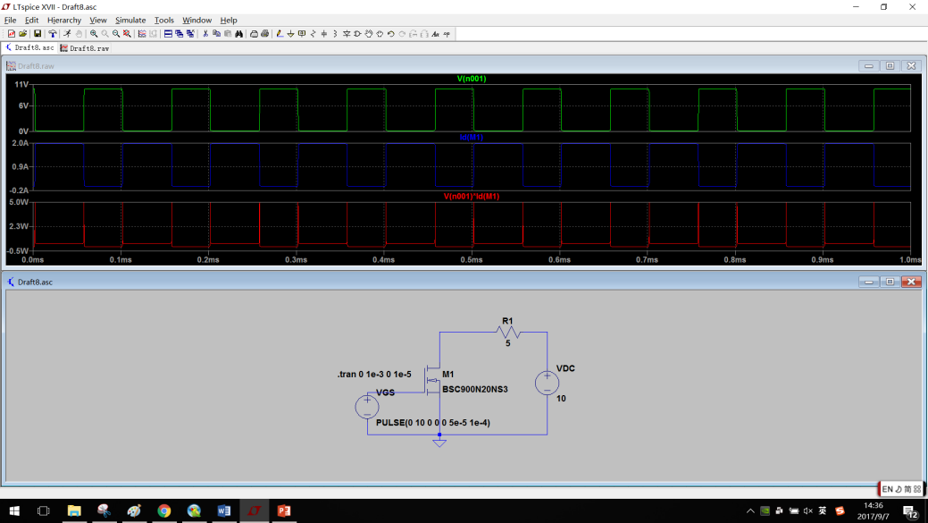

1. **DC-sweep直流扫描**

In this part, we aim to study the output characteristics of MOSFET. To be more specific, a study of the relationship between **VDS** (the voltage across the MOSFET) and **Id** (the current flowing through it) under different gate voltage **VGS** should be looked into.

在这个部分，我们旨在学习MOSFET 的输出特性。更确切的说，研究在不同的门极电压下**VDS**（MOSFET 的之间的电压）和**Id**（流经它的电流）之间的关系。

***Simulate*** 🡪 ***Edit Simulation Cmd*** 🡪 choose ***DC sweep*** options

Now we have 2 variables VGS and VDC. Typically, what DC-sweep does is for each VGS, change the value of VDC and get the corresponding Id and plot them in one figure. Thus we have VGS represents test condition while VDC represents excitation.

现在我们有两个可变的VGS和VDC。通常直流扫描是对于每个门极电压，改变VDC的值得到相应的Id并且把它们画在一张图上。因此，我们设置不同VGS门极电压，和VDS电源电压如下：

Configurations are given as follows where VDC changes from 0 to 150V for each VGS and VGS ranges from 4.5V to 10V.

VGS从4.5V 到10V ，每个步长为0 .5V，VDC从0变化到150V的设置如下图。

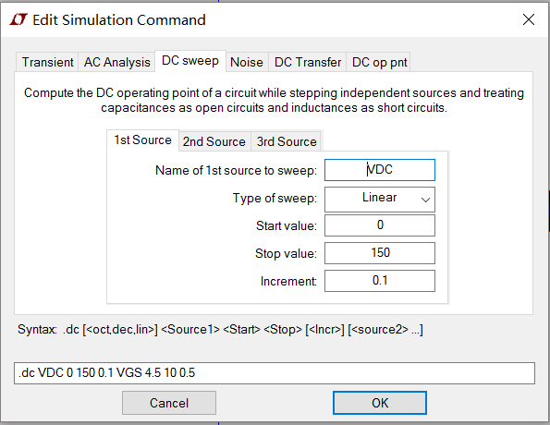 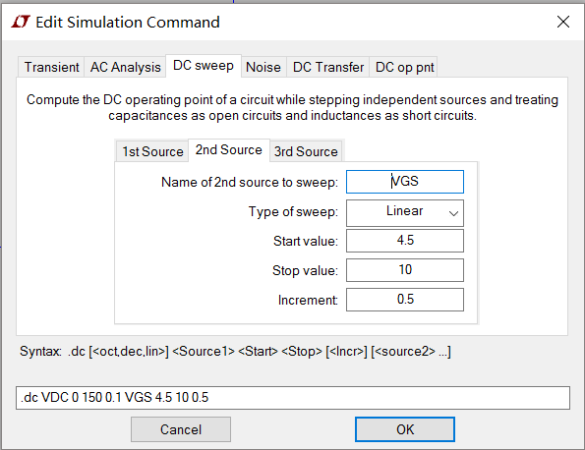

Then run the simulation.

然后开始仿真。

In plot pane, right-click on the bottom to set x-axis as V(n001) which is VDS and then add traces of Id(M1).

在这个窗格中，右键点击底部表示VDS的x轴，然后添加Id（M1）。

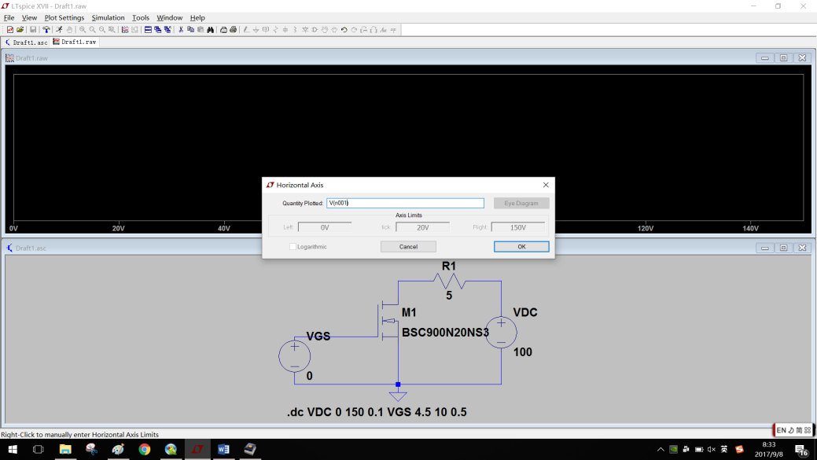

The result should be like as below.

结果如下图所示。

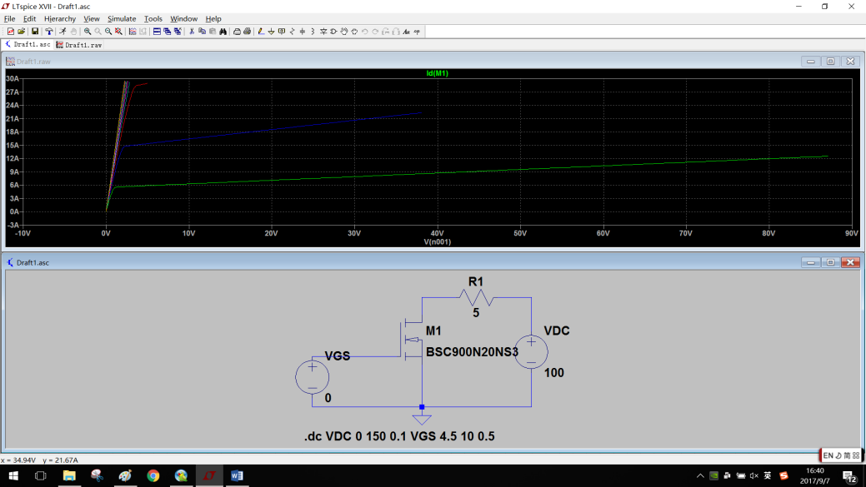

1. **Import model导入模型**

So far you have got all the basic knowledge required to carry out real-time simulation as well as DC sweep to test the characteristics of a MOSFET of certain model. However, there does exist this kind of situation where a specific component is not included in the LTspice library. For example, there is no IGBT model in the library. Thus here a brief tutorial of how to import model from Spice file will be offered.

你已经学了对一个确定的MOSFET模型进行时域仿真和直流扫描的全部知识。但是，当需要对一个LTspice的库里没有的元件进行仿真的时候。比如，库里没有IGBT的模型。因此下面讲解如何导入Spice给出的模型。

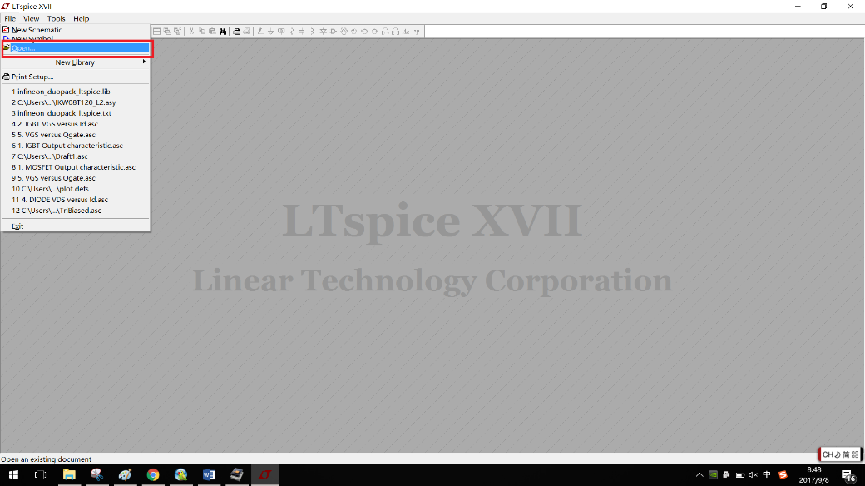

File 🡪 Open

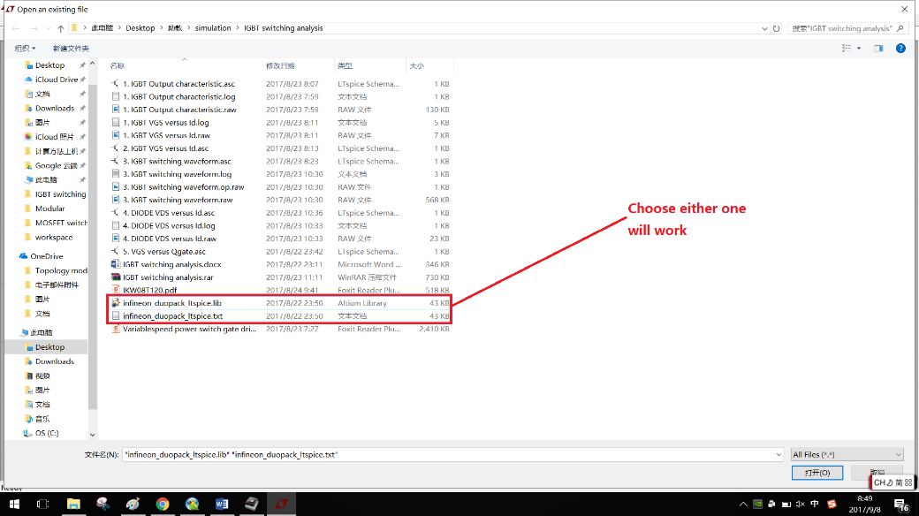

Open the corresponding file in the directory.

打开目录中相应的文件。

Here we aim to test the characteristics of IKW08T120. In the lib file, select the corresponding model and right-click on it. Click on ***Create Symbol***.

这里我们旨在测试IKW08T120的特性。在库文件中，右键选择相应的模型。点击***Create Symbol。***

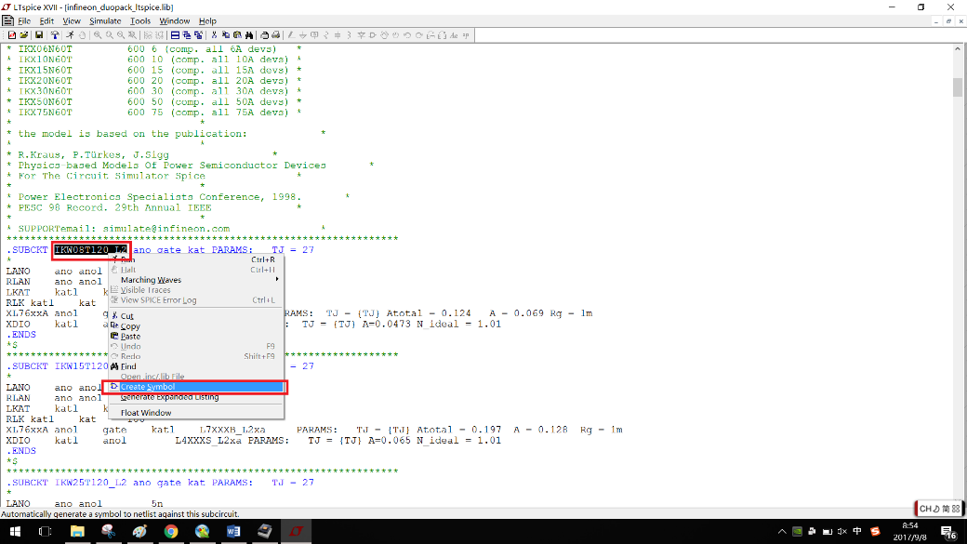

Then you create the IGBT of model IKW08T120. Save it and usually it will be in the directory LTspiceXVII\lib\sym\AutoGenerated. To save it in your personal directory would also be possible.

然后你创建IGBT的一个模型IKW08T120。保存它，通常会在目录LTspiceXVII\lib\sym\AutoGenerated里。保存在你个人的目录也可以。

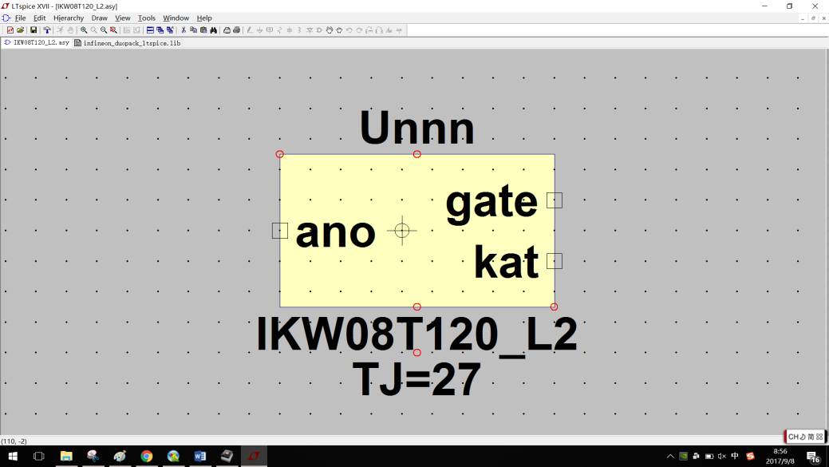

Now create a new schematic. Click on the icon ***Component***. In the corresponding directory, you would be able to find your newly-import model.

现在创建一个新的电路图。点击***Component。***在相应的目录中，你会看到你新导入的模型。

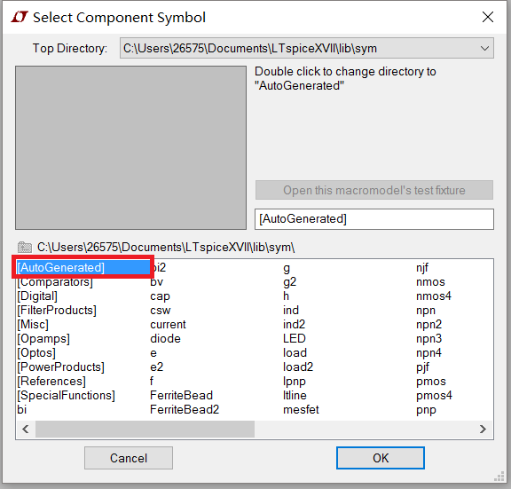 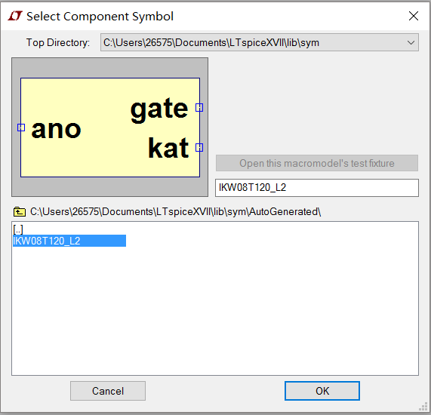

Then import it to your workspace so that you could carry out your simulation.

然后把它导入你的项目中，然后你就能进行你的仿真了。